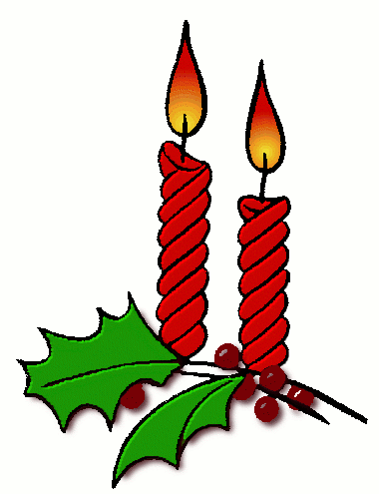
THE FIRST NOEL

The first Noel, the angel did say
Was to certain poor shepherds
In fields as they lay
In fields where they lay keeping their sheep
On a cold winter’s night that was so deep
Noel, Noel, Noel, Noel,
Born is the King of Israel

JOY TO THE WORLD

Joy to the world the Lord has come
Let earth receive her King
Let every heart prepare Him room
And heaven and nature sing 3x

Joy to the world the Savior reigns
Let men their songs employ
While fields and floods, rocks, hills and plains
Repeat the sounding joy 3x

He rules the world with truth and grace
And makes the nations prove
The glories of His righteousness
And wonders of His love 3x
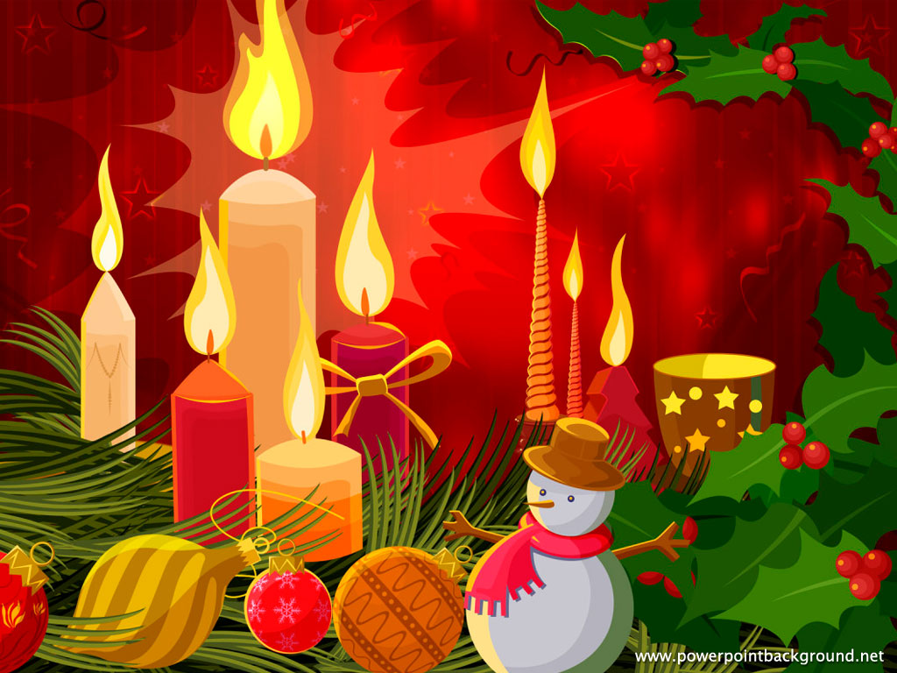
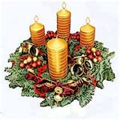
SILENT NIGHT

Silent night Holy night, All is calm, all is bright
Round yon Virgin mother and child
Holy infant so tender and mild
Sleep in Heavenly peace 2x

Silent night Holy night, Shepherds quake at the sight
Glories stream from heaven afar
Heavenly hosts sing "alleluia"
Christ the savior is born 2x

Silent night Holy night, Son of God loves pure light
Radiant beams from Thy holy face
With the dawn of redeeming grace
Jesus Lord at thy birth 2x 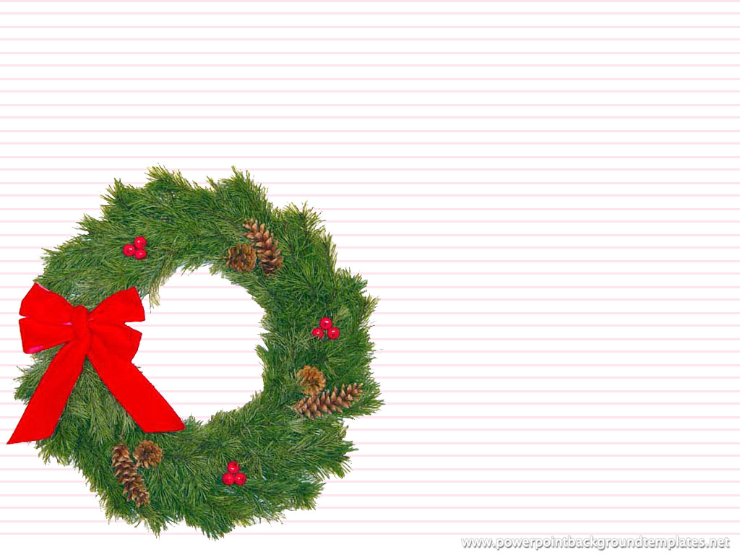
OH HOLY NIGHT

Oh holy night the stars are brightly shinning
It is the night of the dear Savior’s birth
Long lay the world in sin a error pining
Till He appeared and the soul felt its worth

A thrill of hope the weary world rejoices
For yonder breaks a new and glorious morn

Fall on your knees Oh hear the angel voices
O night divine O night when Christ was born
O night divine O night O night divine

